SCHOOL UNIFORM ORDER FORM

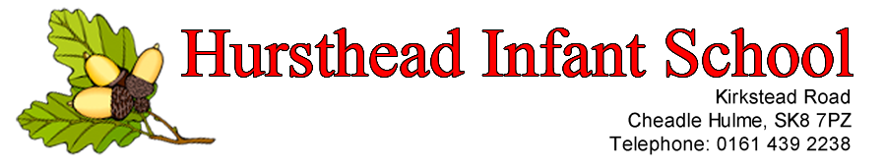
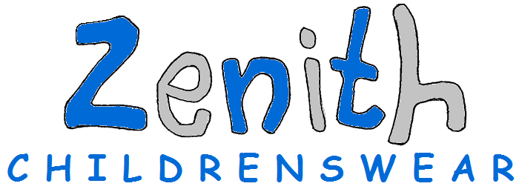

GARMENT SIZES
AGE 3-4 5-6 7-8 9-10 11-12
telephone: 0161 428 1620
email: zenithchildrenswear@gmail.com
ITEM | SIZE | NO. REQUIRED | PRICE EACH | TOTAL COST PER ITEM
Red Sweatshirt |  |  | £9.25 | £
Red Cardigan |  |  | £12.50 | £
White Polo Shirt |  |  | £6.35 | £
Red Expandable  Book Bag | Embroidered |  | £7.00 | £
Red Gym Bag  INFANTS ONLY | Printed |  | £4.50 | £
ORDER TOTAL COST |  |  |  | £

Please Note – For the perfect fit, remember Charles KIRK labels reflect the actual measurement of the garment and are NOT a 'to fit' size
Charles Kirk Sweatshirt and Sweat Cardigan Sizes
Age | 3/4 | 4/5 | 5/6 | 7/8 | 9/10 | 11/12 | 13
Chest size  Garment (inches) | 24 | 26 | 28 | 30 | 32 | 34 | 36

Polo Shirt Sizes
Age | 3/4 | 5/6 | 7/8 | 9/11 | 12/13
Chest size  to fit (inches) | 22/24 | 26/28 | 30 | 32 | 34

Please make cheques payable to Zenith Childrenswear.
Please complete clearly, as this information will be used to deliver your order.
Hursthead School
Name of child ...................................................................... Class ......................
Contact number .......................................................
Office use.
Date received

